Annual Parent/Teacher Asbestos Notification

TO: Parents and Staff of St. John Paul II Classical Catholic School

FROM: Mrs. Monica Burke, Principal

DATE: September 22, 2022

St. John Paul II Classical Catholic School has asbestos Management Plan prepared in compliance with the USEPA Asbestos Hazard Emergency Response Act (AHERA). This plan and subsequent updates are available for inspection Monday through Friday during normal school hours in the Main School Office.

In May of 2020 a Six-month Periodic Surveillance review, required by the AHERA regulation was conducted by qualified personnel to re-evaluate the condition of asbestos containing materials at the facility.

The Surveillance review also evaluated Operations and Maintenance procedures that will keep asbestos materials in good condition.

If you have any questions, please contact Mrs. Monica Burke, our designated person for asbestos activities.

________ yes, I am interested in signing up my child for:

_____ Reading/Phonics

_____ Math

Child’s name __________________________________________

Parent’s Signature________________________________________

Grade that student is currently in: _______

Check Number ______

Mom’s/Dad’s cell number _________________________________

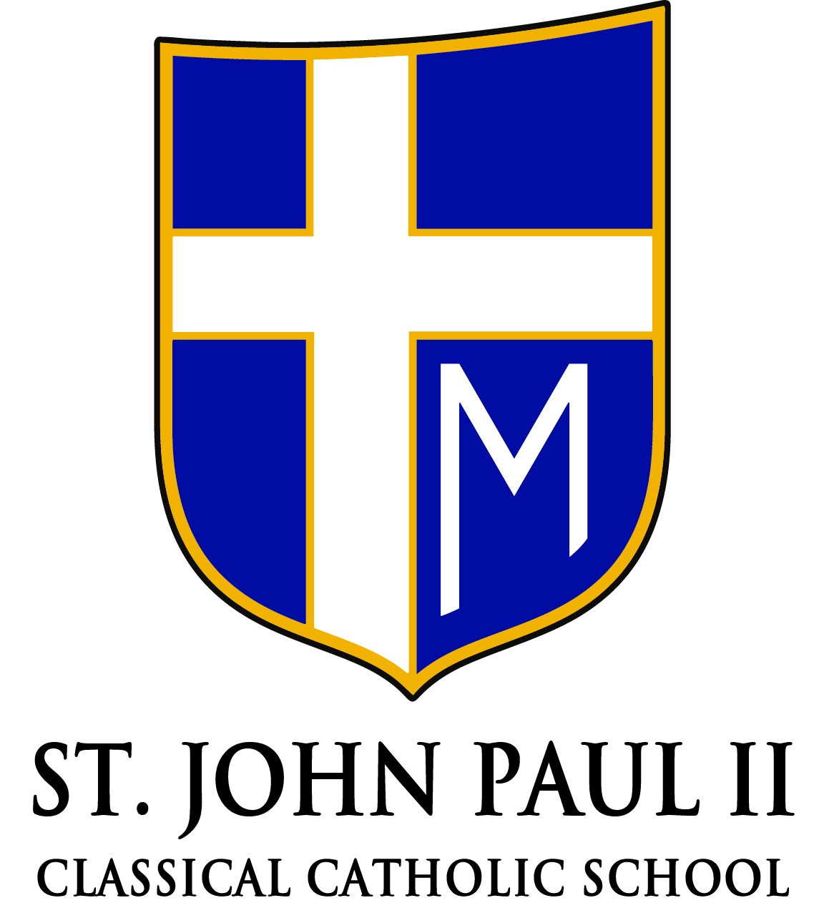

1590 Riverbank

Lincoln Park, MI 48146

(313)386-0633 (313)928-1326 fax

[www.jp2catholic.com](http://www.jp2catholic.com)

**Mrs. Monica Burke** *Principal*

**Fr. David Bechill**

Christ the Good Shepherd

*Pastor*

Accredited by the Michigan Association of Non-Public Schools

