C

**AOD Tuition Assistance 2025-2026 School Year**

To current and new families,

The Archdiocese of Detroit has a tuition assistance program each school year for Catholic families, as well as a limited amount of funds for non-Catholic families.

**December 16, 2024-** Online Application Opens

The application is filled out online through FACTS. Applying for assistance does not mean there is a commitment in coming, it just gives an approximate amount of funds that one would receive in assistance.

(Note: new families to FACTS do not need to have an account, one can create an account when applying for assistance)

**February 28, 2025-** DEADLINE for online application and pastor verification form

Pastor Verification forms are to be filled out and returned to the parish office by this date as they need to be marked in FACTS that they have been received.

**The FACTS online application must show “complete” in the FACTS system by the deadline date to be eligible.**

In addition to the AOD tuition assistance, there are some other funds for tuition assistance.

**St. Anne’s Scholars Fund-** open to any student whose family demonstrates financial need and a desire to attend a K-8 school within the Archdiocese of Detroit.

**St. Martin de Porres Scholarship Fund-** created to provide scholarship grants to K-8 students demonstrating financial need and involved and interested in Latin American communities.

**Education for Brighter Future-** provides scholarships to students and families who desire a catholic or private school education at Wayne County and Pontiac schools and demonstrates a financial need.

Families may apply for students entering grades K-5. Once in the program, a student can remain through 8th grade provided the financial need qualification is met. (Applications will be open in the spring for the subsequent school year)

All information regarding tuition assistance can be found on the AOD website: [www.detroitcatholicschools.org/tuition-assistance-scholarships](http://www.detroitcatholicschools.org/tuition-assistance-scholarships)

If you have any questions regarding tuition assistance, feel free to contact Elizabeth Campbell (bookkeeper) at epokrzywnicki@christgoodshepherd.org

**Classical Education in a Proudly Catholic, Welcoming Community**

**St. John Paul, pray with us this day, for the wisdom to live our faith, in our school in our homes, and in our communities.**

**We are *Learning~*Growing*~Believing~*Succeeding as Disciples of Christ**

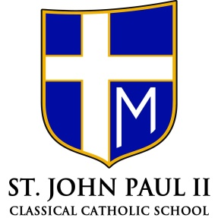

1590 Riverbank

Lincoln Park, MI 48146

(313)386-0633 (313)928-1326 fax

[www.jp2catholic.com](http://www.jp2catholic.com)

**Fr. David Bechill**

*Pastor*

**Melissa Manczak**

*Principal*

Accredited by the Michigan Association of Non-Public Schools

