Sterilite 7 Quart Latch Box**Preschool & Kindergarten Supply List: Mrs. Szarek**

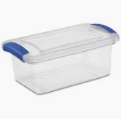

* 1 – 6qt or 7qt plastic storage bin with an attaching lid
* 1 - Backpack
* 1 - Lunchbox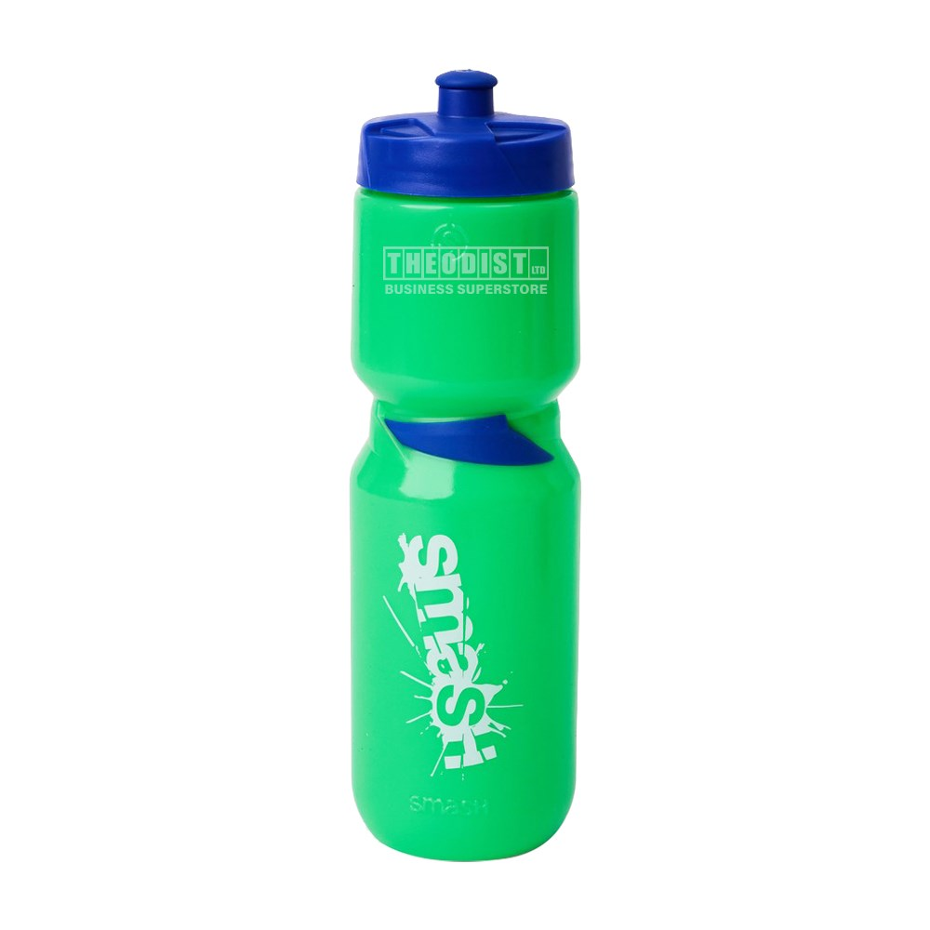
* 1 - Pop-Top Plastic Water Bottle **(Please No Wide Mouth or Metal Bottles)**
* 1 - 1" Binder
* 1 - Large Packs of Elmer's Glue Sticks
* 1 - Personal Sized Whiteboard 8.5" x 11" (These can be found at many stores for $2-$4)
* 2 - Large Pencil Pouches
* 1- White Elmer's Liquid Glue
* 1 - Blunt-tip Scissors **(Metal Please, Not Plastic)**
* 1 - Watercolor Set
* 1 - Pair of Over the Ear Headphones
* 3 - Boxes of Kleenex
* 1 - Complete Change of Clothes
* 1 - Ream of White Copy/Computer Paper
* 1 Ream of Astrobight Blue Copy/Computer paper

**Preschool Only**

* 1 - Folder
* 1 - Large Tote Bag with Handles to hold Naptime Materials:
  + Small Pillow
  + Small Blanket

**Kindergarten Only**

* 2- Folders
* 2 - Wide Ruled Notebooks