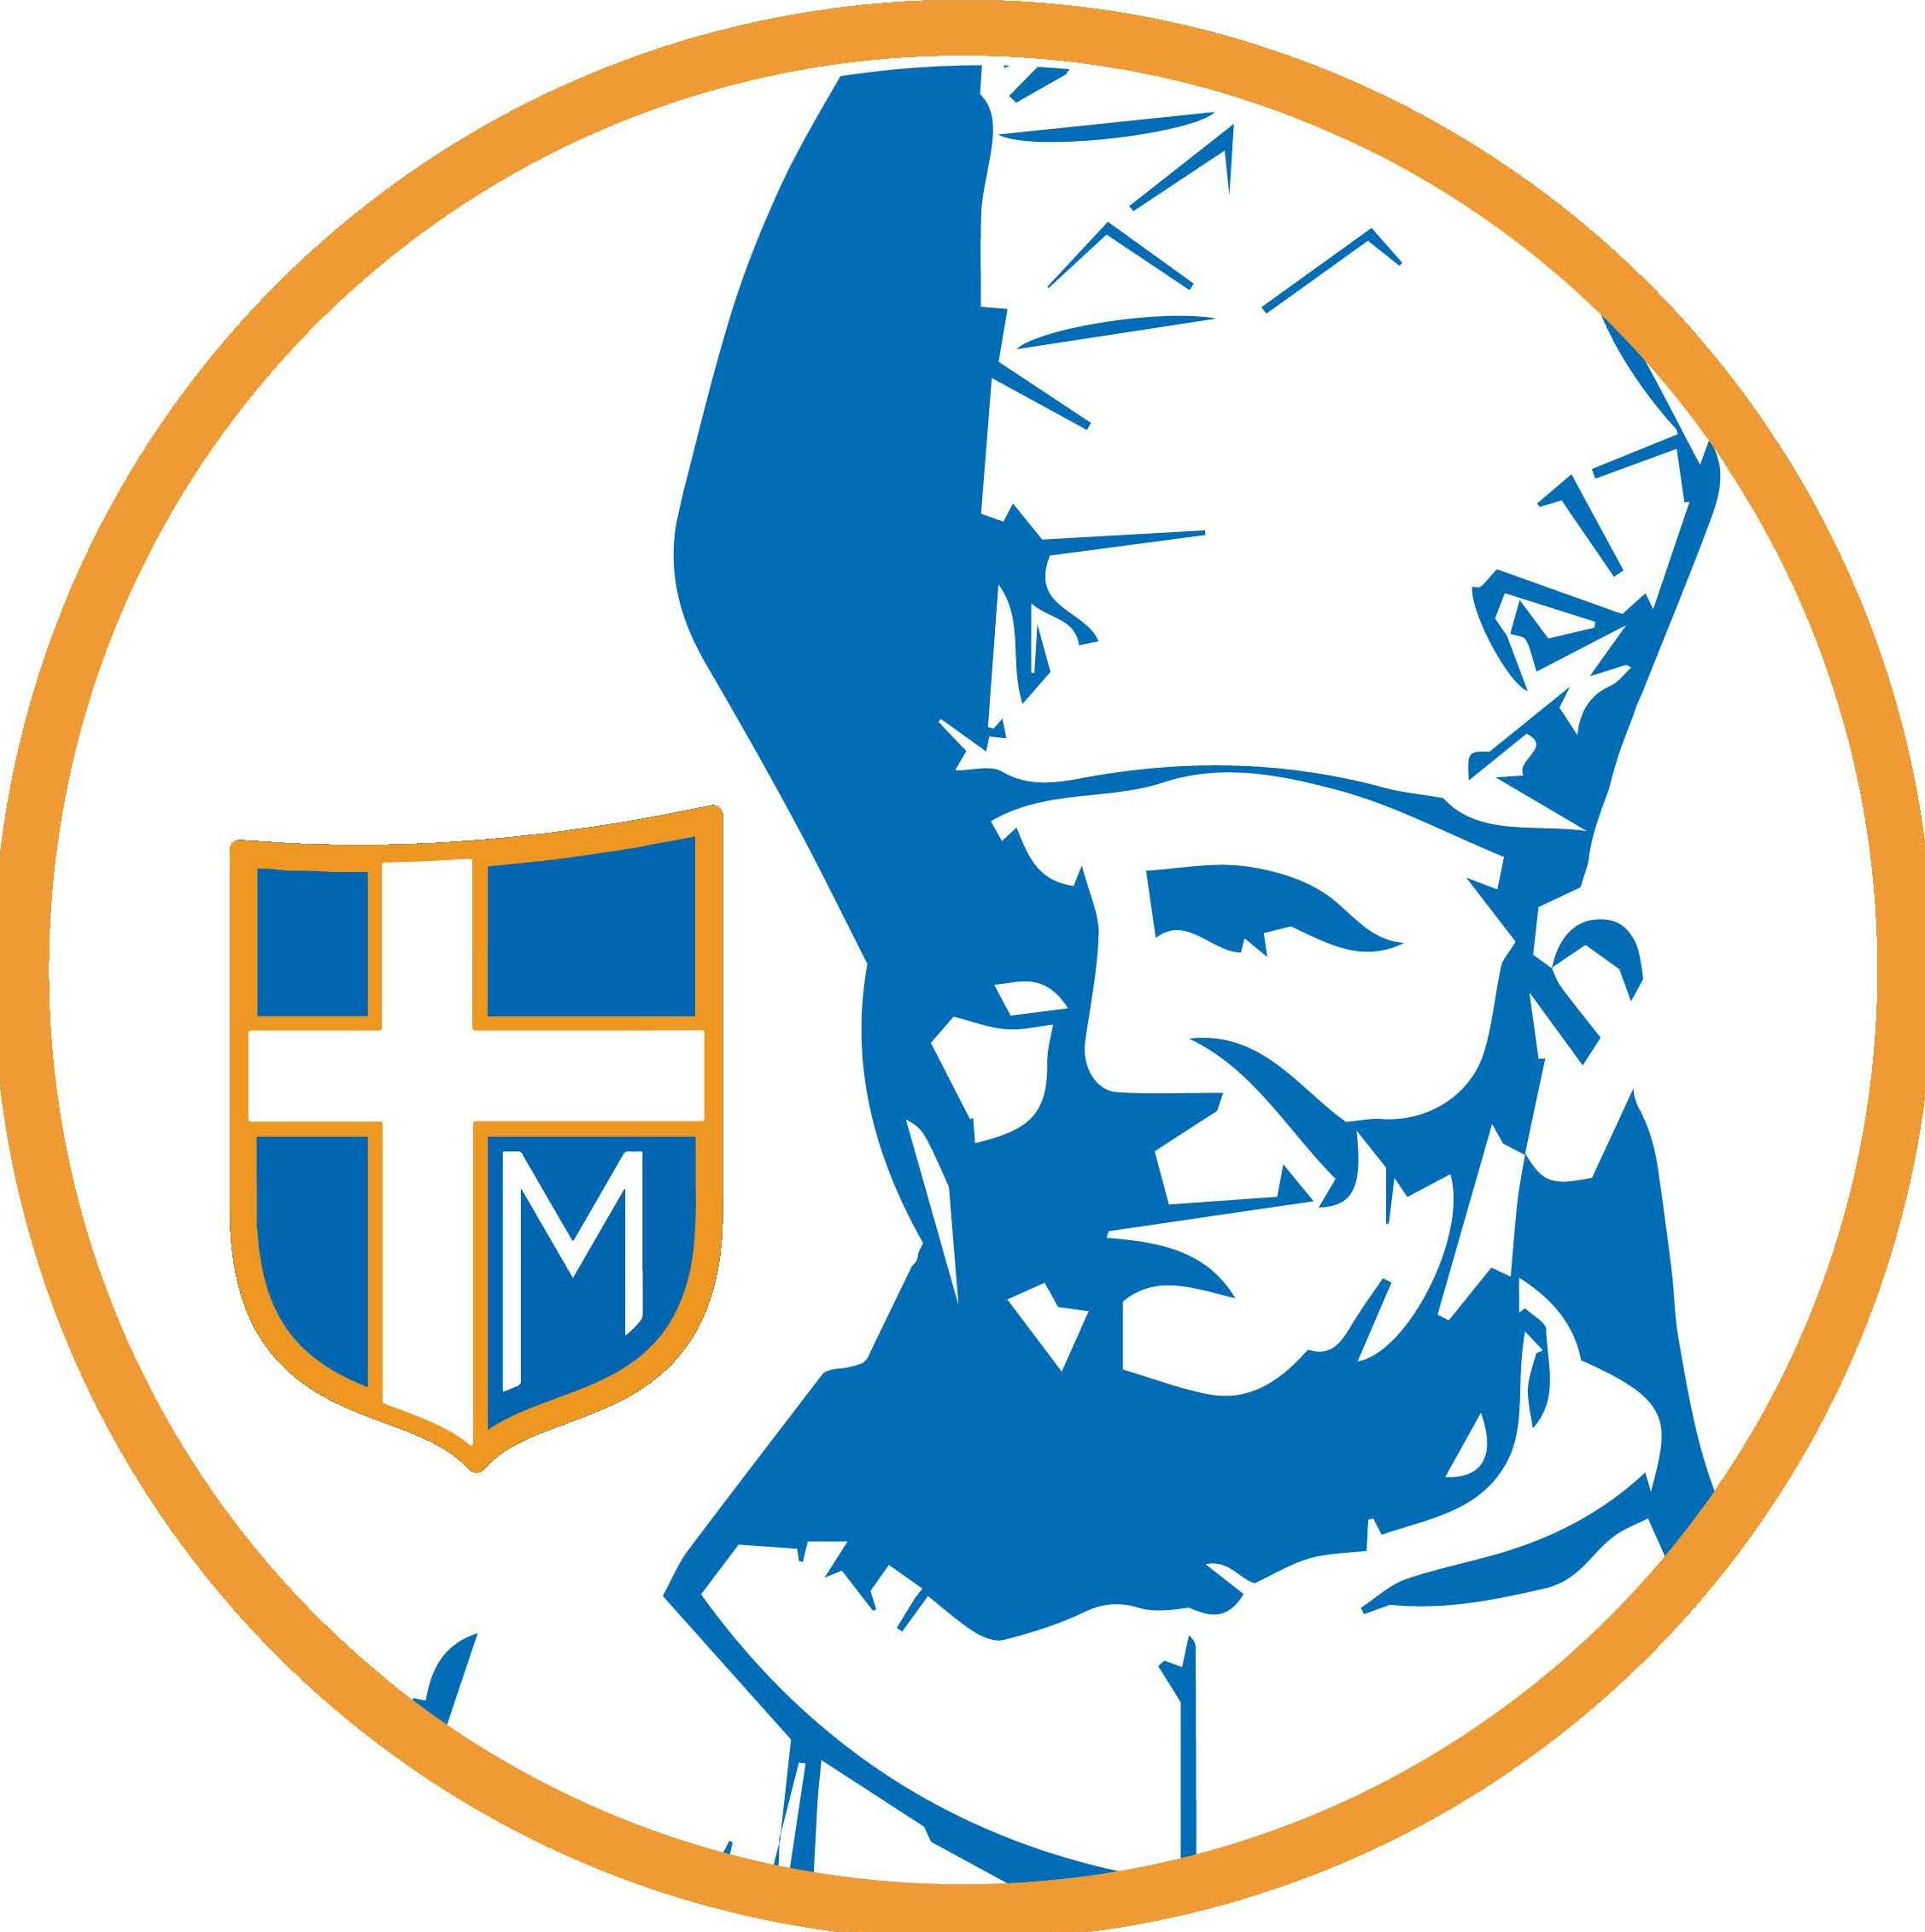
ST. JOHN PAUL II
CLASSICAL CATHOLIC SCHOOL

Kid’s Club Times & Fees
Afternoon Care

3:20-4:20 pm
1 child - $7.00
2 children - $10.00 | 3:20-6:00 pm
3 children - $15.00 | 1 child - $20.00
 | 2 children - $26.00
3:20-5:20 pm | 3 children - $33.00
1 child - $14.00
2 children - $20.00
3 children - $30.00

*After 6 pm late fee: $15.00 for every 5 minutes late.

NOTE:
Student must be enrolled in school full day at St. John Paul II CCS in PS4-8th grade to participate in Kid’s Club.
The billing cycle is each month through FACTS and payments are due 14 days after your invoice is received.

